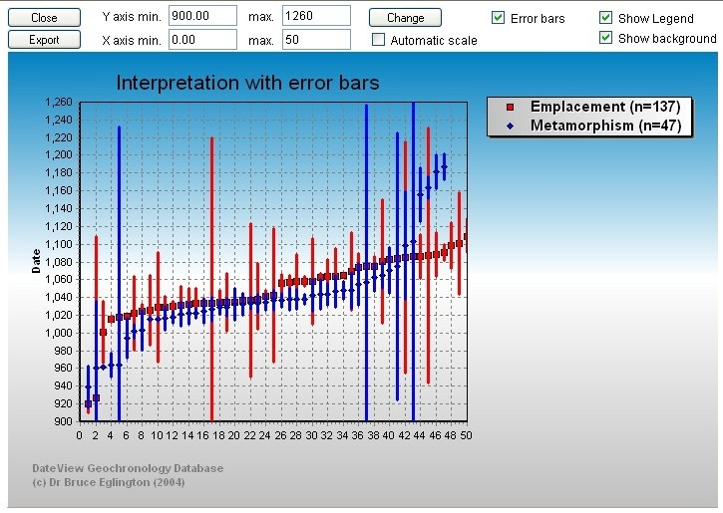
DateView is a web-based database which facilitates the comparison of geochronological and isotope information according to user-captured categories such as:
- Structural provinces or terranes
- Different geochemical associations
- Pre-, syn- or post-tectonic associations
- Identified boundaries
- User-defined groups
Records may be specified as visible only to defined groups so that confidential data can also safely be stored along with published information.

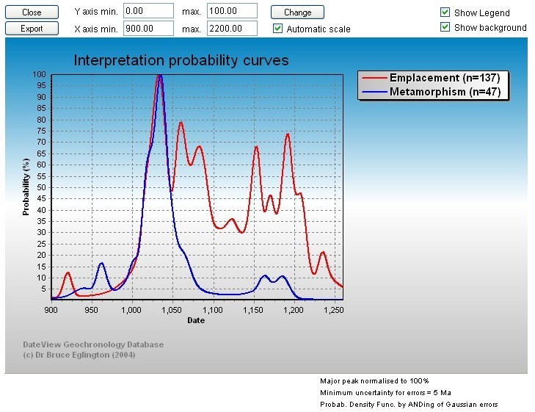

Querying the database is easy, via drop-down lists for fields such as:
- Country
- Unit
- Lithology
- Interpretation
- Start and end date
- Reference
- Material analysed
- Isotope system
- All the user-captured categories
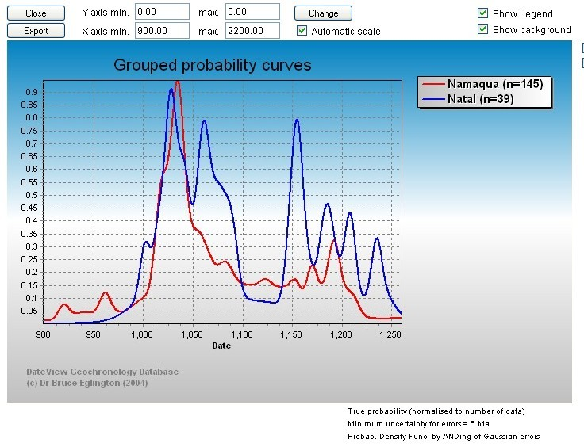
Various graphs illustrate or summarise relationships between individual records or groups of records. Different colours are used for each of up to 5 user-selected interpretations or date bands.
Dates may be graphed as symbols with error bars or summarised as probability density functions. This form of diagram emphasizes intervals in which the dates for many records overlap.
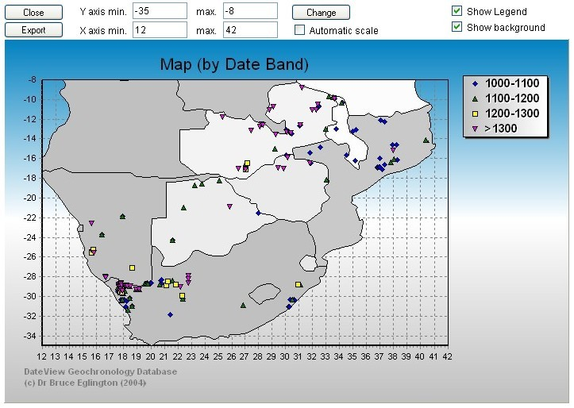

Simple maps may be constructed to illustrate the distribution of rocks with different interpretations or to show up to 5 date bands.

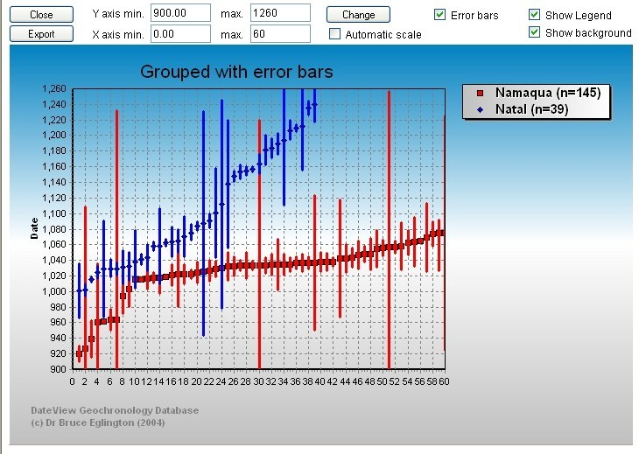
Other diagrams may also be constructed, for instance to illustrate how initial ratios or epsilon values change through time or to investigate the cooling history of selected structural domains.

Users with appropriate permission may download the results of queries for offline plotting, use in GIS packages or to create summary tables for use in publications. Data to produce graphs offline may be downloaded by any user.
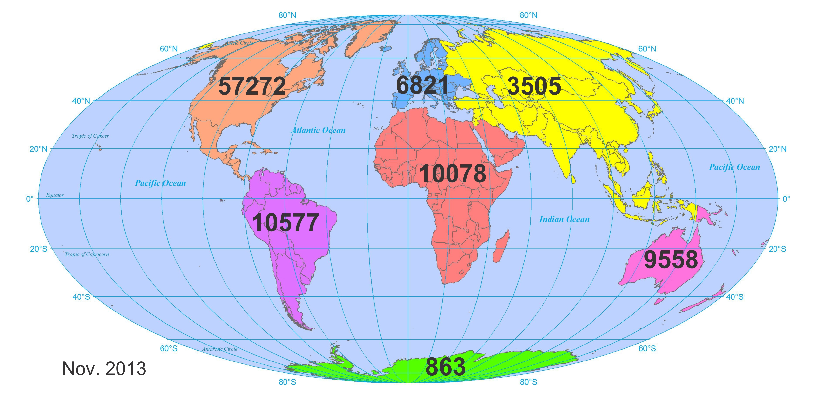
DateView continues to be developed. As at November 2013 it contains more than 106,000 records, distributed across all seven continents. Of these, about 84,000 are public domain.

Records in DateView provide information on initial isotope compositions, in addition to recording standard geochronological details. These may be used to identify global or regional changes in source composition for academic and exploration investigations.
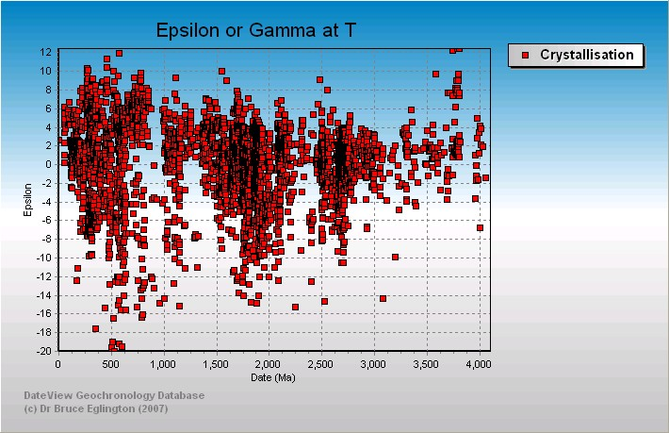
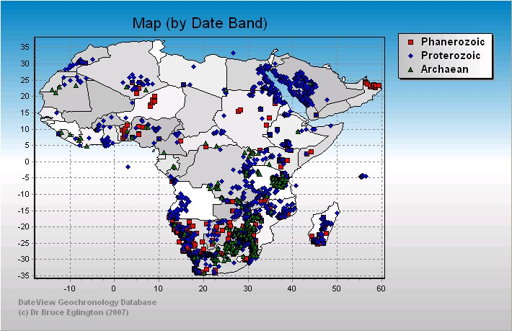
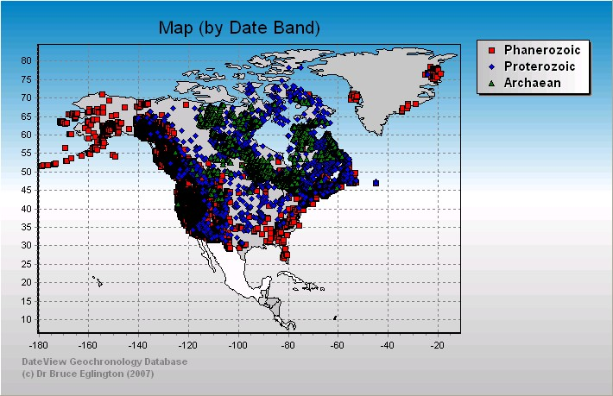
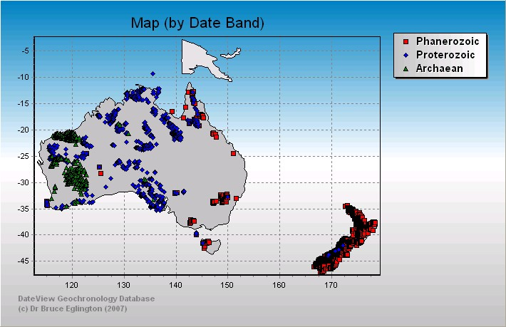
Many, but not all, records also have locality information, so permitting investigations of geographic variability.

Compilations are easily exported from DateView for use in GIS.

Records in DateView may also be linked to records for lithostratigraphic units, tectonic domains, ore deposits or large igneous provinces (LIP’s), all stored in the StratDB database. StratDB provides an alternative (and more limited) view of the geochronological data in DateView. It does, however, provide a mechanism to link rock ages and isotope signatures to other attribute information for units, domains, ore deposits and LIP’s.

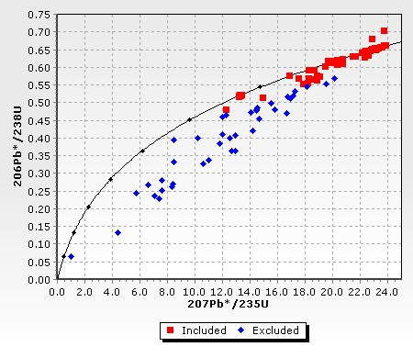

Visualising detrital zircon data

DateView also stores and illustrates individual sample analyses such as U-Pb and Lu-Hf for detrital zircon grains.

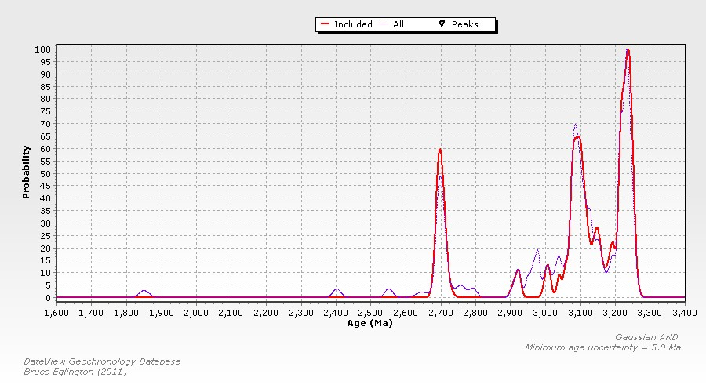

These data may be viewed relative to concordance or as probability plots and initial Hf isotope compositions of the grains may also be assessed.
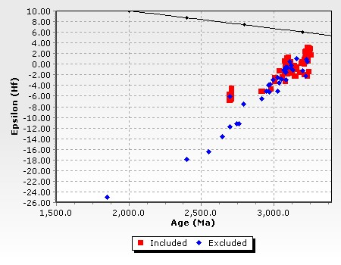

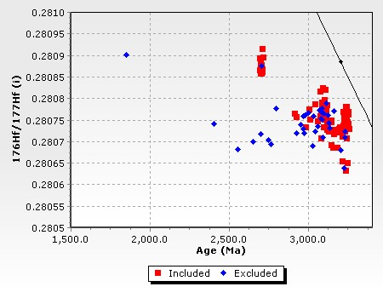

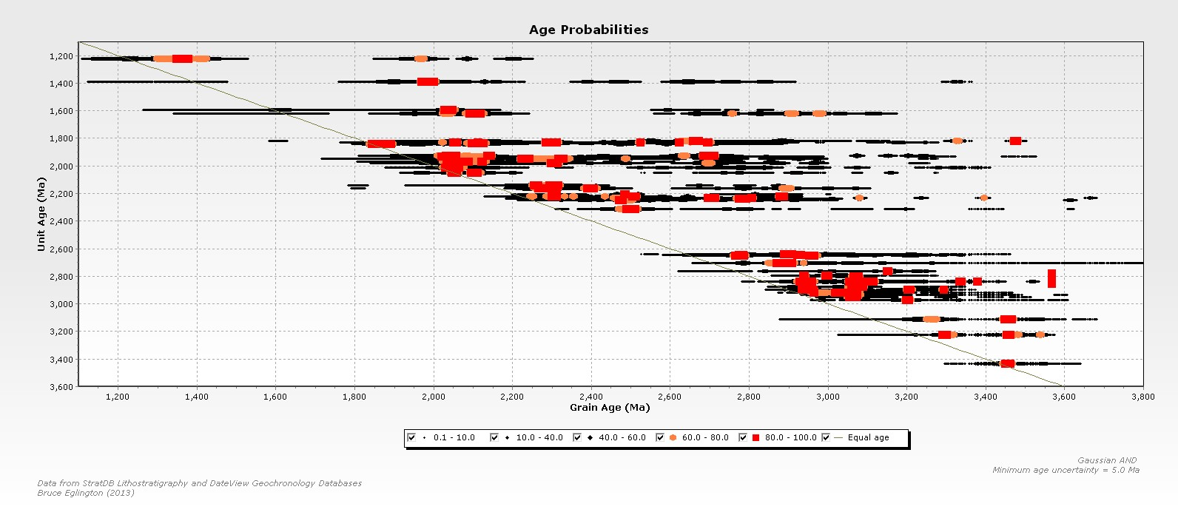
If lithostratigraphic records exist in the StratDB database for the dated units, it is possible to produce detrital age ‘bar-code’ probability plots to illustrate variations in detrital grain age relative to stratigraphic unit deposition age.

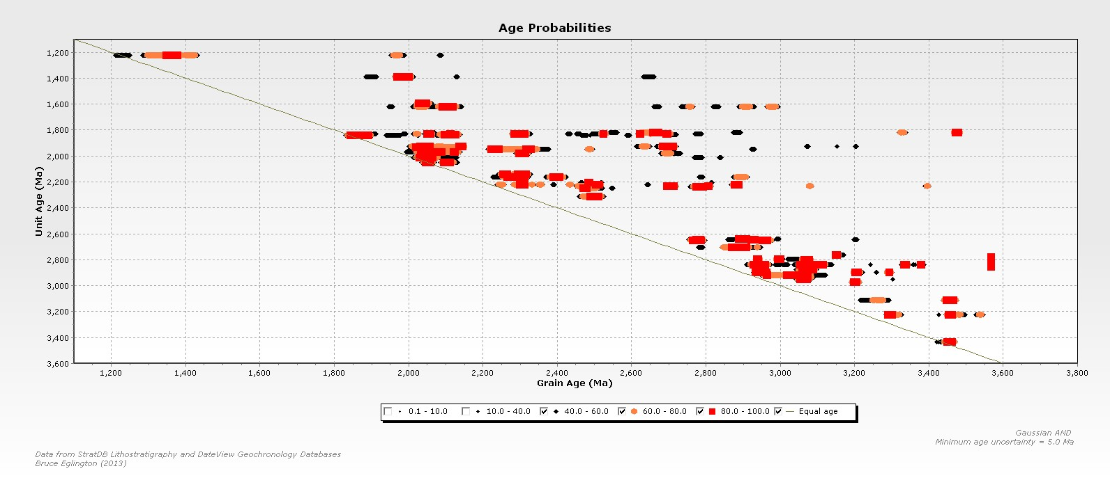
Major peaks in the probability spectra for individual units are shown in orange and red and it is possible to switch off the lower probability parts of spectra so as to emphasise variations in the major grain age sources.

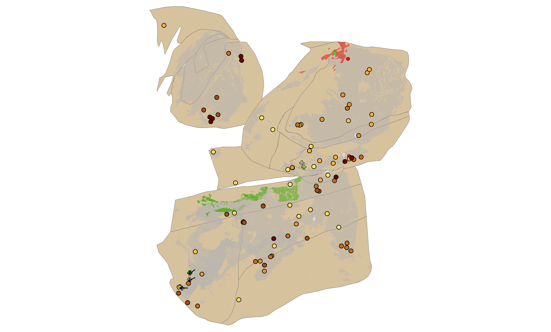
StratDB permits users to identify all records in the DateView database which match the ages of major peaks in probability distributions for individual lithostratigraphic units.

Here, potential provenance areas are illustrated for some ~1940 Ma stratigraphic units from the Kalahari and Pilbara Cratons, assuming that the Vaalbara supercraton was only just breaking up. Open plus symbols are the detrital samples and brownish yellow circles are potential provenance areas (darker brown is older).

